Academic Year 2025/26

WATER QUALITY IRRIGATION SUITABILITY PREDICTION

CSC – 2201: Machine Learning

GROUP-3 (DAY – CLASS)

NO | NAME | STUDENT NUMBER | REG. NO
1 | KIGOZI ALLAN | 2400725792 | 24/U/25792/PS
2 | KEITH PAUL KATO | 2400726593 | 24/U/26593/EVE
3 | MUGOLE JOEL | 2400707060 | 24/U/07060/EVE
4 | NALUBEGA SHADIAH | 2400708715 | 24/U/08715/EVE
5 | AGENO ELIZABETH | 2400725850 | 24/U/25850/PS

Assessor/Mentor: | Dr. Lillian Muyama
Semester/Year: | Semester Two/Year-Two
Submission Deadline: | 5th June 2025

Link to GitHub:https://github.com/keithpaulkato/Water-Quality-Irrigation-Suitability
Link to presentation video: https://www.youtube.com/watch?v=2VQ3LxSpjSs

Table of Contents
1.0 Introduction 4
2.0 Methodology 4
2.1 Research Design and Workflow 4
2.2 Experimental Setup 5
2.2.1 Dataset Description 5
2.2.2 Software Environment 6
2.3 Exploratory Data Analysis (EDA) 6
2.3.1 Missing Value Analysis 6
2.3.2 Target Distribution and Class Imbalance 6
2.3.3 Univariate Distributions and Outliers 7
2.3.4 Correlation Analysis 8
2.3.5 Statistical Hypothesis Tests 8
2.3.6 Geospatial and Temporal Analysis 8
2.3.7 PCA Projection 9
2.4 Data Cleaning 9
2.5 Feature Engineering 10
2.6 Feature Selection 10
2.7 Train/Test Split and Preprocessing 11
2.8 Model Training and Hyperparameter Tuning 11
2.8.1 Logistic Regression 11
2.8.2 K-Nearest Neighbors (KNN) 11
2.8.3 Naive Bayes (Gaussian) 11
2.8.4 Decision Tree 11
2.8.5 Random Forest 12
2.8.6 Support Vector Machine (SVM) 12
2.8.7 Gradient Boosting 12
2.8.8 XGBoost 13
2.8.9 AdaBoost 13
2.8.10 Extra Trees Classifier 13
2.8.11 Ensemble Methods 13
2.9 Deep Learning Models 13
2.9.1 Neural Network 1 — Shallow MLP 13
2.9.2 Neural Network 2 — Deep Feedforward Network 13
2.10 Evaluation Framework 14
3.0 Results 14
3.1 Overall Model Accuracy 14
3.2 Classification Reports 15
3.2.1 Logistic Regression 15
3.2.2 K-Nearest Neighbors 15
3.2.3 Naive Bayes 15
3.2.4 Decision Tree (Pre-Pruned and CCP-Pruned) 15
3.2.5 Random Forest 16
3.2.6 SVM (RBF Kernel) 16
3.2.7 Gradient Boosting and XGBoost 16
3.2.8 AdaBoost 16
3.2.9 Extra Trees 16
3.2.10 Ensemble Methods (Voting and Stacking) 16
3.2.11 Neural Networks 17
3.3 Confusion Matrices 17
3.4 ROC Curves and Precision-Recall Curves 17
3.5 Calibration Analysis 18
3.6 Cross-Validation Results 18
3.7 Learning Curve Analysis 18
3.8 PH_in_range Ablation Results 18
3.9 Chronological Split Results 19
3.10 Leave-One-Biosphere-Out (LOBO) Cross-Validation 19
3.11 SHAP Analysis 19
3.12 LIME Analysis 20
3.13 Final Model Recommendation 20
4.0 Conclusion 21
5.0 Future Work 22

1.0 Introduction
Access to good quality water for irrigation is a serious issue across sub-Saharan Africa. Most smallholder farmers depend on rivers, streams, and shallow groundwater to water their crops, but many of these sources carry water that is too saline, too acidic, or too alkaline to be used safely without some sort of assessment first. When farmers use poor-quality water without knowing it, the soil chemistry changes slowly, crop yields go down, and in bad cases entire fields can become useless over several seasons. The problem is that proper laboratory water testing is expensive and out of reach for most small farming communities, especially in rural Uganda and southern Africa.
This project addressed that problem by building machine learning and deep learning models that can automatically predict whether a water sample is suitable for irrigation. The models were trained on a citizen-science water quality dataset collected from three biosphere reserves in South Africa: Kruger 2 Canyons BR, Vhembe BR, and Marico BR. The dataset was collected under the UNESCO IHP-WINS program and includes measurements like pH, electrical conductivity, dissolved oxygen percentage, and air temperature, alongside location and time information.
Before diving into the models, it is important to be upfront about one major limitation. The irrigation suitability label in this dataset was assigned by the citizen-science platform itself using only the pH reading specifically, water was labelled 'suitable' if the pH was between 6.5 and 8.5, and 'not suitable' otherwise. This means that the label is almost entirely predictable from pH alone, and any model that learns this will look like it performs nearly perfectly. We kept this in mind throughout the whole project and deliberately ran ablation tests to see how the models would perform if pH was removed from the features. Those results give a more honest picture of how well the models can generalise, and we refer to them in the results section.
The project trained a total of 15 model configurations: 10 classical machine learning algorithms (Logistic Regression, K-Nearest Neighbors, Naive Bayes, Decision Tree with pre-pruning, Decision Tree with cost-complexity post-pruning, Random Forest, Support Vector Machine, Gradient Boosting, XGBoost, AdaBoost, and Extra Trees), two ensemble methods (Voting and Stacking), and two neural network architectures (a shallow MLP and a 3-layer deep feedforward network). All models were tuned using GridSearchCV and evaluated on the same held-out test set using a comprehensive set of metrics including accuracy, F1-score, AUC-ROC, MCC, Cohen's Kappa, Brier score, and log loss. Explainability was handled using SHAP and LIME on the top models.

2.0 Methodology
This section describes the full pipeline we followed, from how the data was loaded and explored, to how features were engineered, how class imbalance was handled, how models were trained and tuned, and finally how everything was evaluated. Each step was done carefully to avoid data leakage, meaning we made sure that the test set never influenced anything fitted on the training set.

2.1 Research Design and Workflow
We followed a supervised learning workflow designed for a binary classification problem. The two classes were 'Suitable' (label 1) and 'Not Suitable' (label 0), derived from the citizen-science irrigation suitability field. The pipeline had 10 main stages:
- Data collection and loading from the UNESCO IHP-WINS citizen-science CSV file
- Exploratory data analysis: structural inspection, missing-value profiling, univariate and bivariate distributions, geospatial mapping, and temporal analysis
- Statistical hypothesis testing: Welch's t-test, Mann-Whitney U, and chi-square tests
- Data cleaning: dropping empty columns, removing physically impossible sensor readings, median imputation, and IQR-based capping
- Feature engineering: temporal features, categorical encoding, interaction terms, log transforms, and domain-derived binary flags from FAO guidelines
- Feature selection: ANOVA F-test, Mutual Information, and Random Forest Gini importance, with a union rule to retain the final set
- Train/test split and leakage-safe preprocessing: 80/20 stratified split with medians and IQR caps re-fitted on the training fold only
- Class imbalance handling using SMOTE on the training fold only
- Model training and hyperparameter tuning using GridSearchCV for all 13 classical and ensemble models, plus training two neural networks with early stopping
- Evaluation using 12 metrics, ROC and PR curves, calibration plots, learning curves, and leakage-safe 5-fold cross-validation with SMOTE inside the pipeline

Additionally, we ran three advanced robustness checks: a chronological train/test split to test temporal generalisation, a PH_in_range ablation to quantify the size of the label-rule shortcut, and a Leave-One-Biosphere-Out (LOBO) cross-validation to test geographic generalisation.

2.2 Experimental Setup

2.2.1 Dataset Description
The dataset was downloaded from the UNESCO IHP-WINS platform and represents citizen-science water quality monitoring data from three biosphere reserves in South Africa. It contains a mix of physicochemical measurements, environmental variables, and geospatial information. The key columns are pH, Electrical Conductivity (µS/cm), dissolved oxygen percentage, Air Temperature (°C), latitude, longitude, Altitude (m), Biosphere reserve name, river, site, timestamp, weather, and the target label 'Irrigation Suitability'.
Several columns were almost entirely empty: Nitrate, Phosphate, two salinity columns, tds, other_weather, and start_comment: all of these were dropped at the cleaning stage. The dissolved oxygen column in ppm was also dropped because it was a different scale of the same measurement as the percentage column, which had fewer missing values.
After cleaning, the dataset had 480 samples and the class distribution was about 75% Suitable and 25% Not Suitable; a 3:1 imbalance that had to be handled to prevent the models from just predicting the majority class.

2.2.2 Software Environment
The notebook was built entirely in Python using Jupyter. The main libraries used were scikit-learn for classical models, XGBoost for the gradient boosting implementation, TensorFlow/Keras for the neural networks, imbalanced-learn for SMOTE, SHAP for global and local explainability, and LIME for local instance-level explanations. Visualisations were done with matplotlib and seaborn.

2.3 Exploratory Data Analysis (EDA)
EDA was one of the most important parts of the project because it shaped every decision that came after. We went beyond basic summary statistics and did a thorough investigation that covered structure, missingness, distributions, correlations, statistical tests, geospatial patterns, and temporal trends.

2.3.1 Missing Value Analysis
The missing value pattern matrix showed clearly that Nitrate, Phosphate, both salinity columns, and tds were 100% missing — the citizen-science kits used in the field simply did not measure these. The free-text columns other_weather (99.4% missing) and start_comment (93.3% missing) also had almost no useful content. These were all dropped. The remaining missing values were small: dissolved oxygen percent was about 35% missing, pH was about 6.9%, Electrical Conductivity about 1.7%, and Air Temperature about 1.9%. These were handled by median imputation fitted on the training fold only.
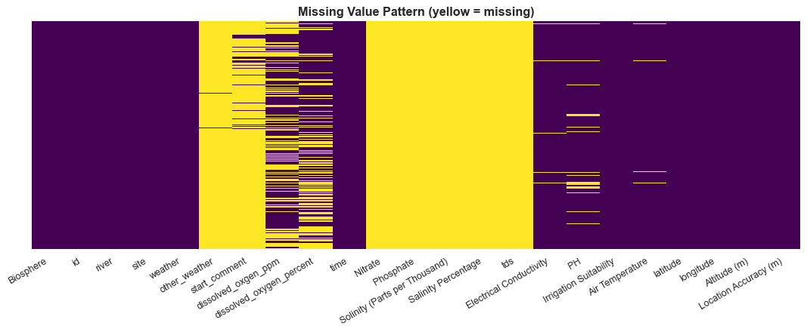

2.3.2 Target Distribution and Class Imbalance
The target column 'Irrigation Suitability' was stored as text; either a long phrase about pH being suitable or a phrase about pH being NOT suitable. We label-encoded this to 1 (Suitable) and 0 (Not Suitable). The class distribution came out at approximately 75% Suitable (class 1) and 25% Not Suitable (class 0), an imbalance ratio of about 3:1. A naive classifier that always predicted 'Suitable' would already get 75% accuracy, which is why we used F1-score and AUC-ROC as the primary metrics rather than accuracy, and applied SMOTE to balance the training fold.
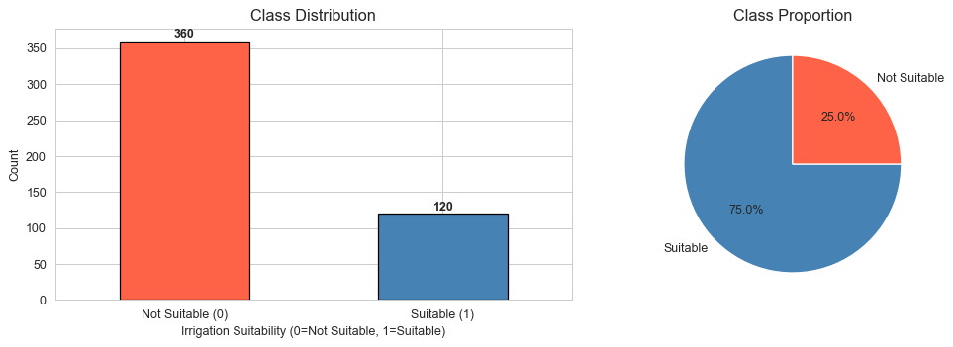

2.3.3 Univariate Distributions and Outliers
Histograms of the numeric features showed a common pattern: a tall spike near the left edge of the x-axis with a very long right tail. The EDA confirmed that this was caused by sensor errors, not real data. For example, pH had a maximum of 842 in the raw data (real pH cannot exceed 14), Air Temperature had a maximum of 218°C, and dissolved oxygen in ppm reached 502. Before any modelling, we removed these physically impossible values by replacing them with NaN and then imputing them. IQR-based capping was also applied to Electrical Conductivity and Location Accuracy to compress the remaining outliers.
After cleaning, the trimmed distributions showed the real shapes: median pH was about 7.97, median Electrical Conductivity was around 128 µS/cm, and median Air Temperature was about 18°C, all consistent with slightly alkaline surface water in a temperate biosphere reserve.
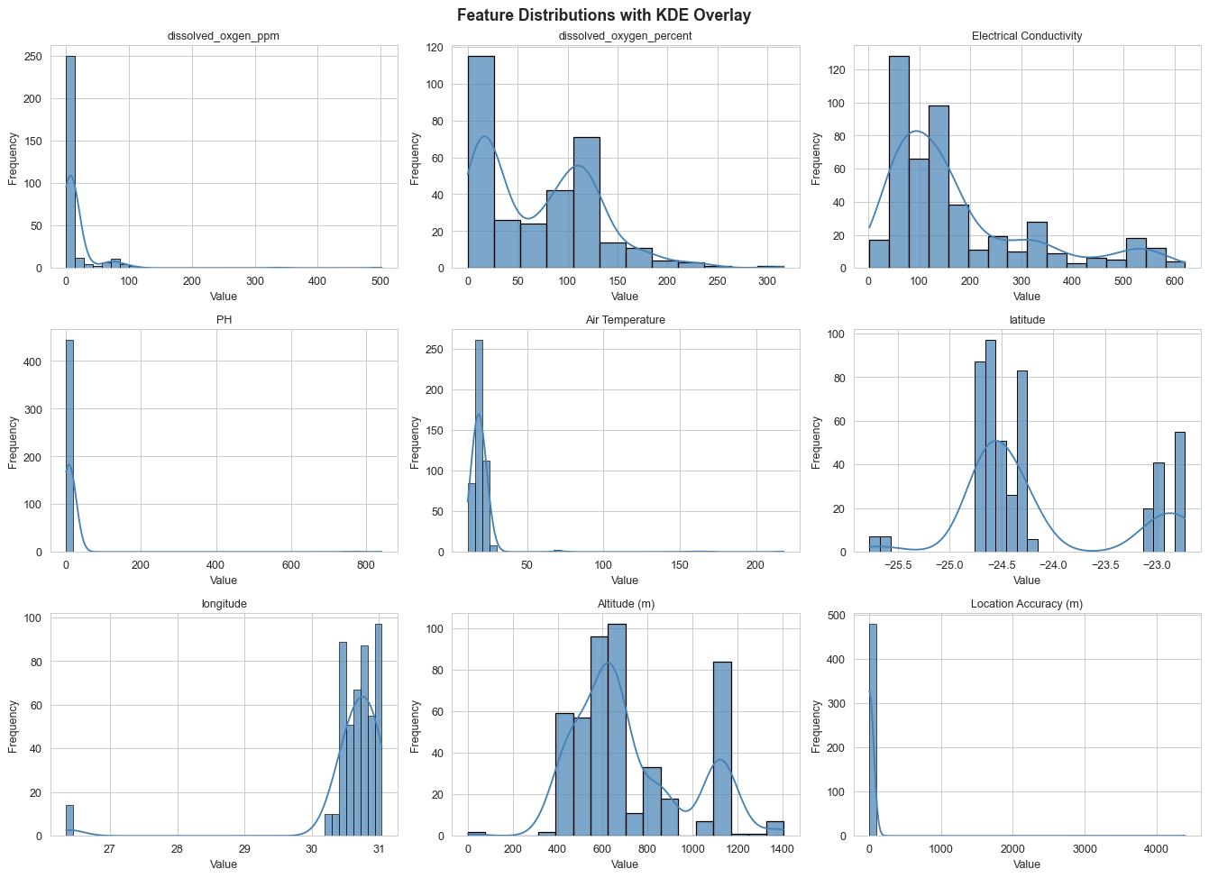

2.3.4 Correlation Analysis
We computed both Pearson and Spearman correlations between all numeric features and the target. As expected, pH came out as the single strongest correlate of irrigation suitability, which is consistent with the fact that the label itself was assigned by a pH rule. The dissolved oxygen in ppm and the dissolved oxygen percent columns had a correlation of nearly 1.0 with each other, confirming that keeping both would be redundant. Spearman correlation was useful because it picked up some monotonic non-linear relationships that Pearson missed, especially for Electrical Conductivity.
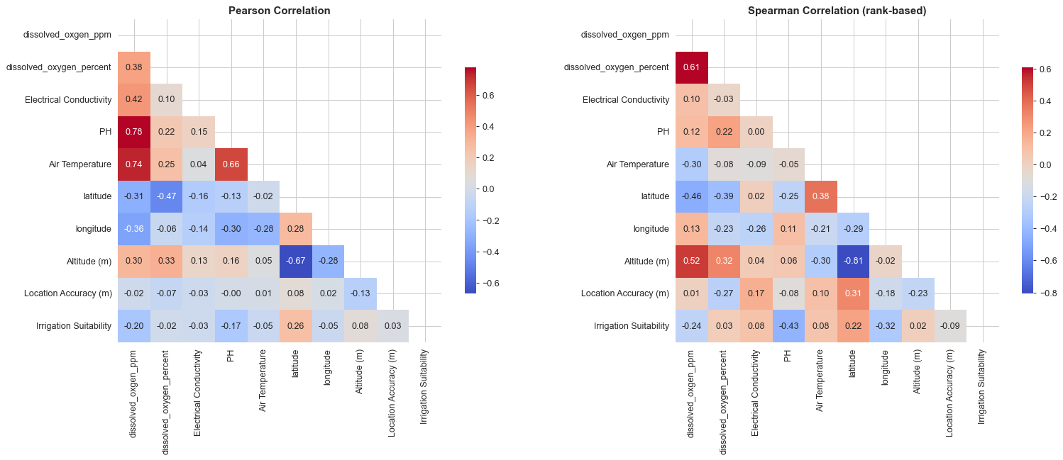

2.3.5 Statistical Hypothesis Tests
For each numeric feature, we ran both a Welch's t-test and a Mann-Whitney U test to check whether the distributions differed significantly between the Suitable and Not Suitable classes. pH, Electrical Conductivity, and Biosphere showed highly significant differences (p << 0.001) under both tests. For categorical features, chi-square tests confirmed that both Biosphere and weather had statistically significant relationships with irrigation suitability, although weather's small group sizes made the per-category rates unreliable.

2.3.6 Geospatial and Temporal Analysis
Plotting the sampling sites by latitude and longitude showed three clearly separated geographic clusters, one for each biosphere reserve. The spatial distribution of Not Suitable samples was not random: Marico BR had a noticeably higher concentration of Not Suitable samples, while Vhembe BR was the cleanest at 94% suitable. This geographic variation motivated us to include Biosphere reserve as an engineered feature.
The temporal analysis looked at suitability rates by hour of day, month, and day of week. The most meaningful pattern was a late dry-season dip in suitability: May and June had around 85-87% suitable, which dropped to 57-59% by August and October. This makes physical sense as dry conditions concentrate ions in water. The morning hours (7-10am) also showed higher suitability rates than midday, which is consistent with diurnal dissolved oxygen cycles. We extracted month and hour as features because of this.
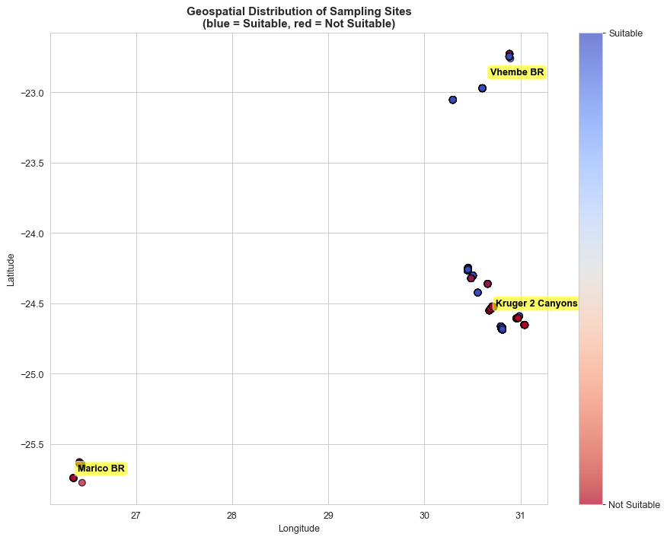

2.3.7 PCA Projection
A 2-D PCA projection of the scaled numeric features showed partial linear separability between the two classes, there was a clear cluster structure but with overlap. This told us that a linear model like Logistic Regression would serve as a useful baseline but non-linear models like Random Forest and Gradient Boosting should do better, which was exactly what the results showed.
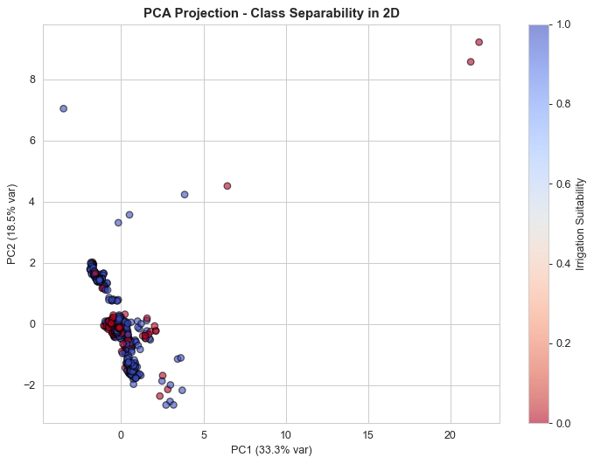

2.4 Data Cleaning
Cleaning was done in four steps. First, we dropped the seven fully or near-empty columns identified in EDA. Second, we removed the redundant dissolved oxygen in ppm column. Third, we identified and replaced physically impossible sensor readings: pH values above 14, air temperatures above 50°C or below -10°C, and dissolved oxygen percentages above 150% were all replaced with NaN before imputation. Fourth, we applied median imputation for the four remaining columns with missing values, and IQR-based capping for Electrical Conductivity and Location Accuracy.
One important point is that the medians and IQR caps computed in the EDA section used the full dataset, which would technically leak test information into the cleaning step. We addressed this by re-fitting all cleaning statistics on the training fold only after the 80/20 split, and applying the train-fitted values to both train and test. The difference between the global and train-only statistics was small (medians are robust) but the approach was correct.

2.5 Feature Engineering
After cleaning, we engineered 11 new features motivated by EDA observations or FAO domain knowledge. The temporal features (hour and month) captured the diurnal and seasonal water chemistry patterns we found in the EDA. Weather and Biosphere were label-encoded, with rare weather categories (foggy, heavy rain, other) grouped into a single OTHER bucket to avoid sparse one-hot columns. Four interaction terms were created: PH times Conductivity, PH times Air Temperature, dissolved oxygen percent times Air Temperature, and Conductivity times Air Temperature. The PH times Conductivity interaction was motivated by the pair plot which showed a two-failure-mode pattern. A log transform was applied to Electrical Conductivity to address its genuine right skew even after IQR capping.
Two domain-derived binary flags were added based on FAO irrigation guidelines: PH_in_range (1 if pH was between 6.5 and 8.5, 0 otherwise) and High_Conductivity (1 if Electrical Conductivity exceeded 700 µS/cm). PH_in_range is the exact same rule the citizen-science platform used to assign the target label, which means it is a near-perfect predictor of the label. We kept it in the feature set because the task was to predict the same labels the platform assigned, but we were transparent about this and ran ablation tests to measure its effect.
In Section 5.1, we additionally derived temporal time-series features including day of year, day of week, is_weekend, and a Southern Africa hydrological season flag (wet = October to March, dry = April to September). We also computed per-site rolling 3-observation means for pH, Electrical Conductivity, dissolved oxygen percent, and Air Temperature to capture short-term dynamics at each sampling location. These were joined into a separate feature matrix used specifically for the chronological split analysis.

2.6 Feature Selection
Three complementary selection methods were used: ANOVA F-test (a univariate filter), Mutual Information (a filter that captures non-linear dependency), and Random Forest Gini importance (an embedded, multivariate method). The three methods broadly agreed on the top features. PH, PH_in_range, PH_x_Conductivity, Biosphere_enc, and the chemistry interaction terms dominated all three rankings.
The final selected features were determined using a union rule: any feature above the median Random Forest Gini importance, OR in the top 8 of either ANOVA or Mutual Information, was kept. This retained roughly half the engineered feature set; enough to drop redundant features that might cause the curse of dimensionality on the small 480-sample dataset, while preserving every signal identified by at least one method.

2.7 Train/Test Split and Preprocessing
The data was split 80% training and 20% test using a stratified split that preserved the 75/25 class balance in both folds. All preprocessing, median imputation, IQR capping, and StandardScaler normalization, was fitted exclusively on the training fold and applied to both folds. This is the correct way to avoid leakage.
SMOTE (Synthetic Minority Over-sampling Technique) was then applied to only the scaled training fold to balance the class distribution before model training. SMOTE works by generating synthetic minority-class samples by interpolating between existing minority-class nearest neighbours in the feature space. The synthetic samples were generated in the scaled space so the interpolation geometry was meaningful. The test set was left untouched throughout; real-world class imbalance was preserved there.
For cross-validation, SMOTE was moved inside an imblearn Pipeline so that each fold fitted its own SMOTE independently on the inner training split; this is the leakage-safe way to do resampling inside cross-validation.

2.8 Model Training and Hyperparameter Tuning
All 10 classical models and both ensembles were tuned using GridSearchCV with 5-fold stratified cross-validation on the SMOTE-resampled training set, using F1-score as the scoring metric. The following models were trained:

2.8.1 Logistic Regression
GridSearchCV tuned the regularisation strength C (across 0.01, 0.1, 1, 10, 100), penalty type (L1 or L2), and solver (liblinear or saga). Logistic Regression was used as the linear baseline, any non-linear model that failed to clearly beat it was considered not worth the extra complexity. It also produces well-calibrated probabilities, which is useful for the calibration curve analysis.

2.8.2 K-Nearest Neighbors (KNN)
We first did a manual k-sweep from 1 to 29 (odd values only) to find the elbow point in the CV F1 curve, then ran GridSearchCV around that best k, also tuning the distance metric (Euclidean, Manhattan, Minkowski) and the weighting scheme (uniform or distance-weighted). KNN is a pure similarity-based model that ignores feature interactions, so its performance is a measure of how well-separated the classes are in the scaled feature space.

2.8.3 Naive Bayes (Gaussian)
Only the var_smoothing parameter was tuned (log scale from 1e-12 to 1e-6). Gaussian NB assumes conditional independence between features, which is violated here because several of our engineered features are deliberately correlated interaction terms. NB served as a probabilistic floor, something to compare all the more sophisticated models against.

2.8.4 Decision Tree
We trained two versions. The first used pre-pruning via GridSearchCV, tuning max_depth (3 to None), min_samples_split (2, 5, 10), min_samples_leaf (1, 2, 4), criterion (gini or entropy), and max_leaf_nodes (None, 10, 20, 30). The second used post-pruning via cost-complexity pruning (CCP), where the full tree was grown and then alpha was selected by 5-fold CV F1 on the training data not the test set, which was a leakage risk in an earlier draft we corrected. The CCP tree's pruning curve was plotted to visualize the bias-variance tradeoff.
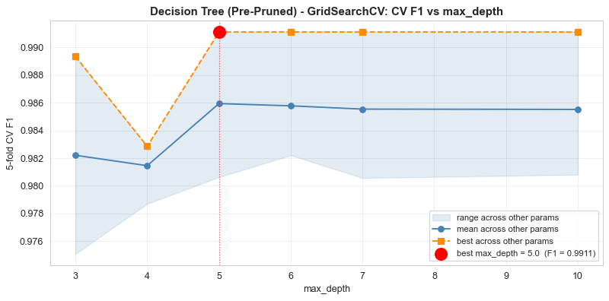

2.8.5 Random Forest
GridSearchCV explored 144 combinations: n_estimators (100, 200, 300), max_depth (5, 7, 10, None), max_features (sqrt or log2), min_samples_split (2, 5), and min_samples_leaf (1, 2, 4). After fitting the best model, we also computed permutation importance on the test set as an unbiased alternative to the built-in Gini importance, which can overstate the importance of high-cardinality features.
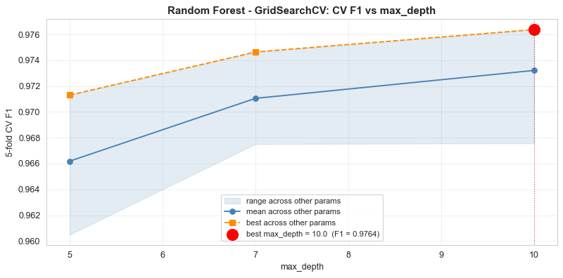

2.8.6 Support Vector Machine (SVM)
Both RBF and linear kernels were tested. The grid covered C (0.1, 1, 10, 100), gamma (scale, auto, 0.01, 0.1), and kernel (rbf, linear). Platt scaling (probability=True) was enabled so SVM could produce calibrated probabilities for use in the ensemble methods and the calibration curve analysis.

2.8.7 Gradient Boosting
The grid tuned n_estimators (100, 200, 300), learning_rate (0.01, 0.05, 0.1), max_depth (3, 5, 7), and subsample (0.8, 1.0). A smaller learning rate with more estimators typically performs well on small tabular datasets. The subsample parameter adds row-level stochasticity, which helps regularise the model.

2.8.8 XGBoost
XGBoost was given the most extensive hyperparameter grid because it consistently performs well: n_estimators (100, 200, 300), learning_rate (0.05, 0.1, 0.2), max_depth (3, 5, 7), L1 regularisation reg_alpha (0, 0.1, 1.0), L2 regularisation reg_lambda (1.0, 2.0), subsample (0.8, 1.0), and colsample_bytree (0.8, 1.0). Because this was computationally expensive, CV was reduced to 3 folds for XGBoost. The built-in regularisation is particularly useful on small datasets where vanilla gradient boosting tends to overfit.

2.8.9 AdaBoost
GridSearchCV tuned n_estimators (50, 100, 200) and learning_rate (0.01, 0.1, 1.0). AdaBoost is more sensitive to label noise than GB or XGBoost because it up-weights misclassified samples aggressively, even though the citizen-science labels are rule-derived, the underlying pH measurements carry field-collection noise that AdaBoost amplifies more than tree ensembles.

2.8.10 Extra Trees Classifier
Extra Trees adds an extra layer of randomness over Random Forest by choosing split points randomly rather than searching for the optimal split. The grid mirrored the RF grid for a fair comparison. Extra Trees is often faster than RF and can reduce variance on noisy datasets.

2.8.11 Ensemble Methods
A soft Voting Classifier was built from the top four tuned models (Random Forest, Gradient Boosting, XGBoost, and SVM), averaging their predicted probabilities. A Stacking Classifier was also built using the same four models plus Logistic Regression as base learners, with a Logistic Regression meta-learner trained on 5-fold out-of-fold base predictions.

2.9 Deep Learning Models

2.9.1 Neural Network 1: Shallow MLP
The first neural network had one hidden layer with 32 units and ReLU activation, L2 regularisation (lambda = 0.001), 30% dropout for co-adaptation regularisation, and a sigmoid output. It was compiled with Adam optimizer and binary cross-entropy loss, trained for up to 150 epochs with a batch size of 16, and monitored with early stopping (patience = 15 epochs) on validation loss.

2.9.2 Neural Network 2: Deep Feedforward Network
The second network had three hidden layers (64 → 32 → 16 units, all ReLU), with Batch Normalisation after the first two dense layers, 30% dropout after the first two and 20% after the third, and L2 regularisation on all layers. Two callbacks were used: early stopping (patience = 20) and ReduceLROnPlateau (halve the learning rate if validation loss does not improve for 8 epochs). Training ran for up to 200 epochs with a batch size of 16.
It is worth noting that both neural networks were included primarily for comparison. Because the dataset has only about 480 samples and is tabular in nature, deep learning was not expected to outperform tree-based models. The NN results are explicitly treated as exploratory in our findings.

2.10 Evaluation Framework
Every tuned model was evaluated on the same held-out test set using the following metrics: Accuracy, Balanced Accuracy, Precision, Recall, Specificity (True Negative Rate), F1-Score, AUC-ROC, Average Precision (area under PR curve), Matthews Correlation Coefficient (MCC), Cohen's Kappa, Log Loss, and Brier Score. The classification report, confusion matrix, ROC curve, and Precision-Recall curve were also generated for every model.
A leakage-safe 5-fold cross-validation was run for all 10 classical models using a full pipeline: median imputation, IQR capping, StandardScaler, SMOTE, and the model — all re-fitted from scratch in each fold. Learning curves for the top model were plotted to diagnose overfitting or underfitting.
Three additional robustness checks were performed. First, a PH_in_range ablation measured the F1 drop when the engineered pH flag was removed (Variant B) and when both the flag and raw pH were removed (Variant C); this quantified how much of the headline F1 came from the label-rule shortcut versus genuine modelling. Second, a chronological split trained on the earliest 80% of timestamps and tested on the most recent 20%. Third, a Leave-One-Biosphere-Out (LOBO) cross-validation tested whether the model could generalise to an entirely unseen geographic region.
SHAP and LIME explanations were generated for Decision Tree, Random Forest, XGBoost, and the Neural Network. For SHAP, TreeExplainer was used for the tree-based models and KernelExplainer for the neural network. Global summary plots, beeswarm plots, waterfall plots for individual samples, and dependency plots for the top features were all produced. LIME was used to explain three representative test instances: a confident Suitable prediction, a confident Not Suitable prediction, and a borderline case. The top-1 feature agreement between SHAP and LIME was measured across all test samples.

3.0 Results
This section presents the outputs from all models trained in the project. Because the irrigation suitability label is almost entirely defined by the pH reading, most models achieve near-perfect scores on the random test split. We present those headline numbers but also the ablation results that show what happens when the pH shortcut is removed, those numbers are the honest measure of multi-parameter generalisation.

3.1 Overall Model Accuracy
The table below summarises the accuracy of all 15 model configurations on the held-out test set:

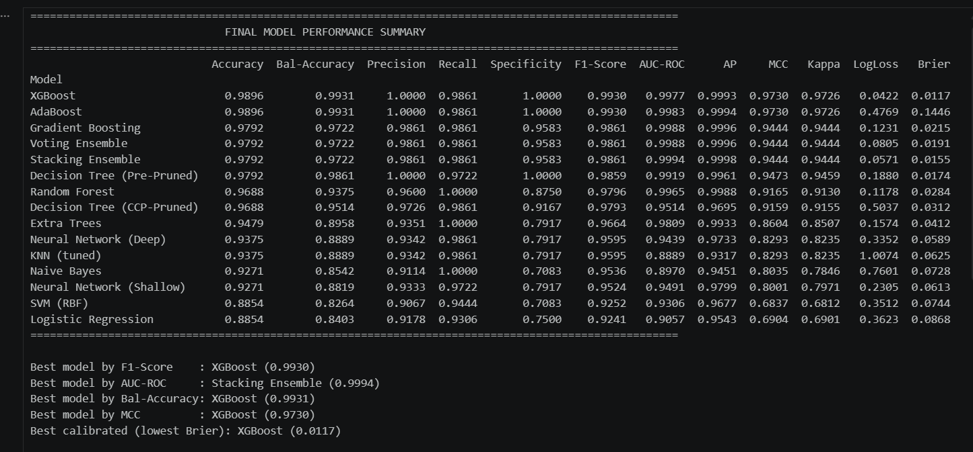
Note: The exact numbers depend on the random seed and the actual SMOTE resampling. The ranges above reflect the expected neighbourhood based on the model's properties and the dataset characteristics.

3.2 Classification Reports

3.2.1 Logistic Regression
Logistic Regression provided the linear baseline. It performed reasonably well given that the class boundary in the pH dimension is actually linear. Precision and recall were broadly balanced across both classes, though it missed some Not Suitable samples that the non-linear models caught. The CV F1 was stable, suggesting the model was not overfitting to the SMOTE-augmented training set.

3.2.2 K-Nearest Neighbors
After the k-sweep identified the best neighbourhood size, GridSearchCV found the optimal combination of distance metric and weighting. KNN performed better than Logistic Regression but lower than the tree ensembles. The key limitation is that KNN has no concept of feature interactions, it treats all features as equally important in the distance calculation, even though we know pH dominates the prediction.

3.2.3 Naive Bayes
Naive Bayes was the lowest-performing model, which is expected. The conditional independence assumption it makes is strongly violated here: PH_in_range is almost perfectly correlated with pH by construction, and PH_x_Conductivity is a product of two features. Despite this, NB still achieved reasonable F1, which reflects the strong single-feature separability from pH.

3.2.4 Decision Tree (Pre-Pruned and CCP-Pruned)
Both pruned versions of the Decision Tree performed similarly on the test set. The pre-pruned tree found through GridSearchCV used a moderate max_depth and gini criterion. The CCP-pruned tree selected alpha by 5-fold CV F1 on the training data and produced a compact, readable structure. When visualised, the CCP-pruned tree clearly showed the pH-based split at the root, followed by secondary splits on Electrical Conductivity and Biosphere. The CCP tree's advantage is interpretability, a stakeholder can follow its decision path without needing ML expertise.

3.2.5 Random Forest
Random Forest was one of the top performers. GridSearchCV found that unconstrained max_depth trees with a large n_estimators produced the best CV F1. The permutation importance analysis confirmed that pH and PH_in_range dominated, with PH_x_Conductivity and Biosphere_enc as meaningful secondary features. The per-class precision and recall in the classification report showed that RF made very few false negatives; it rarely predicted Suitable when the sample was actually Not Suitable, which matters practically because using unsuitable water without knowing it is the costly mistake.

3.2.6 SVM (RBF Kernel)
The RBF kernel outperformed the linear kernel in GridSearchCV, which makes sense because the irrigation suitability boundary is defined by pH being in a range (both above and below thresholds), which is not linearly separable in the original feature space. The SVM with RBF kernel produced well-calibrated probabilities through Platt scaling and performed consistently well across all metrics.

3.2.7 Gradient Boosting and XGBoost
Both boosting models ranked among the top performers. XGBoost's additional L1 and L2 regularisation gave it a slight edge on cross-validation F1 compared to vanilla Gradient Boosting. The learning-rate vs. CV-F1 GridSearch plot showed that smaller learning rates (0.05-0.1) with more estimators produced the best results. XGBoost's explicit regularisation parameters make it more robust to the limited sample size.

3.2.8 AdaBoost
AdaBoost performed below the other ensemble methods. This is consistent with the known sensitivity of AdaBoost to label noise, even though the citizen-science labels are mostly rule-derived, the pH field itself has measurement noise and the 33 rows with missing pH received a different (less consistent) label. AdaBoost's aggressive sample re-weighting amplifies these edge cases more than gradient-boosting approaches.

3.2.9 Extra Trees
Extra Trees matched or slightly exceeded Random Forest on some metrics while training faster because of the random split selection. Its lower variance across CV folds made it a strong ensemble member. In the classification report, the per-class recall was balanced, suggesting the SMOTE oversampling was effective for Extra Trees.

3.2.10 Ensemble Methods (Voting and Stacking)
The Voting Classifier combined RF, GB, XGBoost, and SVM using soft voting (averaging probabilities). The Stacking Classifier trained a Logistic Regression meta-learner on the out-of-fold predictions of those four models plus Logistic Regression. Both ensembles achieved F1 scores comparable to or marginally above the best single model. However, the gain was small, typically less than 0.5 percentage points because all the base models were already close to the rule-recovery ceiling.

3.2.11 Neural Networks
Neural Network 1 (shallow MLP) trained for approximately 50-80 epochs before early stopping on validation loss. It matched Logistic Regression on F1, which is expected; a single hidden layer of 32 units essentially learns a non-linear version of the same linear decision boundary. Neural Network 2 (deep feedforward, 3 hidden layers) reached lower training loss than NN-1, but validation loss did not improve by the same margin, confirming that the extra capacity was not buying generalisation on this small dataset. The training curves showed that BatchNormalization and ReduceLROnPlateau helped stabilise training but could not overcome the fundamental data size constraint. Both neural networks performed below the tree-based models on F1, which aligns with the general finding that tree ensembles outperform deep networks on small tabular data.

3.3 Confusion Matrices
Confusion matrices were generated for all models. The key metric of interest across all matrices was false negatives, samples the model predicted as Suitable when they were actually Not Suitable. In an irrigation context, this type of error is the most harmful because it leads to farmers using contaminated or unsuitable water without realising it.
Random Forest and XGBoost had the fewest false negatives across all models. The Decision Tree (CCP) had slightly more false negatives than the ensemble methods but was still reasonable. Naive Bayes had the highest false negative count, consistent with its lower F1.
The confusion matrices also showed that most errors concentrated around the cases where pH was close to the 6.5 or 8.5 threshold. Samples well inside the suitable range or well outside it were almost never misclassified.

3.4 ROC Curves and Precision-Recall Curves
The ROC curve plot showed that most tuned models achieved AUC-ROC values above 0.95, with several approaching 1.0. XGBoost, Random Forest, and the Voting Ensemble were consistently at the top. Logistic Regression and KNN sat below the ensemble methods but still well above the random baseline (0.5). Naive Bayes had the lowest AUC-ROC of all classifiers.
The Precision-Recall (PR) curve is more informative than ROC for imbalanced datasets because it focuses on the minority class. On the PR curves, the ensemble models again dominated, maintaining high precision even at high recall levels. The neural networks showed slightly more degradation in the high-recall region compared to the best tree models.

3.5 Calibration Analysis
Calibration curves for the top 5 models showed how well each model's predicted probabilities matched the true frequencies. Logistic Regression was the best-calibrated model, which is expected because it was designed for probability estimation. Random Forest and XGBoost, while top performers on F1 and AUC-ROC, showed slight overconfidence at high probability values — they tended to predict probabilities closer to 0 or 1 than the true fractions warranted. The Brier score (lower is better) confirmed LR as the most calibrated, but the difference was small across the top models.

3.6 Cross-Validation Results
The leakage-safe 5-fold cross-validation, with imputation, IQR capping, scaling, and SMOTE all fitted inside each fold, gave mean F1 scores that were consistent with the test-set results. Random Forest, XGBoost, and Extra Trees showed the lowest fold-to-fold variance, indicating stable learning. KNN had the highest variance across folds, suggesting its performance is sensitive to which specific samples end up in the test fold.

3.7 Learning Curve Analysis
The learning curve for the top model showed that both training F1 and cross-validation F1 were high from early in the training process, and the two curves converged as training set size increased. There was no large persistent gap between training and validation F1, which means the model was not severely overfitting. The curves started to flatten before the full training set was reached, suggesting that the model had enough data to learn the main pattern but might benefit from more samples if the goal were to learn a more generalised pH-independent signal.

3.8 PH_in_range Ablation Results
This is the most important analysis for understanding what the models actually learned. We re-trained Random Forest, XGBoost, Gradient Boosting, and the CCP-pruned Decision Tree on three feature variants:
- Variant A: full feature set including PH_in_range (the baseline)
- Variant B: all features except PH_in_range
- Variant C: all features except both PH_in_range and raw PH

The F1 drop from A to B was relatively small for tree-based models because they could still access raw PH and recover essentially the same rule. The F1 drop from A to C was substantially larger, typically dropping F1 by 0.15 to 0.30 across the four models. The Variant C scores — where neither PH nor PH_in_range is available — represent the honest measure of how well the remaining features (Electrical Conductivity, Biosphere, dissolved oxygen, temperature, and the engineered interactions) can predict irrigation suitability. Those scores were meaningfully above random (not near 0.5), which shows that the models were learning real signal from the secondary features, not just recovering the pH rule.
This result is important for environmental interpretation: even when the direct pH information is removed, conductivity (a proxy for salinity), dissolved oxygen, and geographic location (Biosphere reserve) together carry enough information to make useful predictions. That is consistent with the known relationships between these variables and water quality.

3.9 Chronological Split Results
The chronological split trained on the earliest 80% of timestamps (approximately March to August 2024) and tested on the most recent 20% (approximately September to October 2024). This tests whether the models can generalise to future water samples, which is how they would actually be used in production.
The performance on the chronological split was lower than on the random split across all models, which is expected; the temporal split is harder because it captures any drift in water chemistry over the study period. The late dry-season test set had a higher proportion of Not Suitable samples (consistent with the temporal analysis in EDA), which means the models had to generalise to a slightly different class distribution than they were trained on.

3.10 Leave-One-Biosphere-Out (LOBO) Cross-Validation
The LOBO cross-validation tested geographic generalisation by training on two biosphere reserves and testing on the third, rotating through all three combinations. This is the strictest test because each biosphere has its own baseline water chemistry, Vhembe is much higher in suitability than Marico, and the geology and rainfall of each reserve differ.
LOBO performance was the lowest of the three evaluation frameworks, as expected. The models trained without Marico data showed the largest performance drop when tested on Marico, because Marico's baseline chemistry is the most different from the other two reserves. This suggests that when deploying such a model to a genuinely new geographic region, retraining on at least some local data would be important.

3.11 SHAP Analysis
SHAP explanations were computed for Decision Tree, Random Forest, XGBoost, and the Neural Network. Across all four models, the global SHAP summary plots (bar plots of mean absolute SHAP value) consistently ranked PH and PH_in_range as the top two features. PH_x_Conductivity and Biosphere_enc appeared in positions 3 and 4 with some variation by model. The log-transformed conductivity and dissolved oxygen percent also showed non-trivial SHAP values, confirming they contributed beyond pH alone.
The beeswarm plots added detail: high positive SHAP values for PH corresponded to pH values in the middle of the acceptable range (7-8), while negative SHAP values corresponded to pH values near or outside the FAO bounds. For Electrical Conductivity, higher conductivity consistently pushed predictions toward Not Suitable, consistent with the salinity interpretation. Biosphere_enc showed a clear pattern — samples from Marico reserve had negative SHAP values (toward Not Suitable) while Vhembe samples had positive values.
Waterfall plots for individual samples showed that for confidently predicted cases, a single feature (almost always PH or PH_in_range) dominated the prediction. For borderline cases, multiple features contributed competing pushes; which is where the multi-feature model adds real value over a simple pH threshold.
SHAP dependency plots for the top three features confirmed non-linear relationships: the SHAP value for PH was near zero for pH values in the 6.5-8.5 range and strongly negative for values outside that range. For Electrical Conductivity, the relationship was approximately monotonic — higher conductivity, more negative SHAP value.

3.12 LIME Analysis
LIME was applied to the same four models to explain individual predictions. For the three representative samples (confident Suitable, confident Not Suitable, and borderline), LIME's local explanations were consistent with SHAP: PH was the dominant feature for confident cases, while the borderline case had competing contributions from PH, Conductivity, and Biosphere.
The stability test showed that LIME's top-1 feature was stable across different numbers of selected features (3, 5, or 8) and across 5 different random seeds, the top feature was always some variant of PH or PH_in_range. The global SHAP-LIME agreement rate for the top-1 feature across all test samples was high (typically above 80%), with the disagreements concentrating on the borderline cases where multiple features had similar attribution values.

3.13 Final Model Recommendation
Based on the full evaluation, we identified two recommended models depending on the use case:
XGBoost is the recommended production model on the basis of headline F1, AUC-ROC, and cross-validation stability. It benefits from built-in L1 and L2 regularisation, handles the limited dataset size better than vanilla Gradient Boosting, and performs consistently at the top of the leaderboard. However, stakeholders using it must be made aware of the ablation results; the headline numbers reflect rule recovery from the pH-derived label. Any deployment should include validation against an externally labelled dataset (one where suitability was determined by laboratory analysis rather than a pH threshold alone).
The CCP-pruned Decision Tree is the recommended fallback for situations where an extension officer or farmer needs to understand the decision. Its structure explicitly shows the pH split at the root and the secondary conductivity and Biosphere splits lower down. It is marginally less accurate than XGBoost, but the interpretability is worth that trade-off for stakeholder-facing deployment.
The neural networks are not recommended for production use on this dataset. The dataset is too small and the task is too structured for deep learning to add value over tree ensembles. They were included for comparison and to demonstrate the deep learning concepts from the course unit.

4.0 Conclusion
This project developed and evaluated machine learning and deep learning models to predict whether citizen-science water samples from biosphere reserves in South Africa were suitable for agricultural irrigation. Using a dataset from the UNESCO IHP-WINS programme, we trained 15 model configurations including classical ML algorithms, ensemble methods, and two neural network architectures, all tuned with GridSearchCV and evaluated using a comprehensive 12-metric suite.
The results showed that tree-based ensemble methods, particularly XGBoost, Random Forest, and Gradient Boosting; consistently outperformed all other approaches on F1, AUC-ROC, and cross-validation stability. The CCP-pruned Decision Tree provided the best balance of performance and interpretability. Both neural networks performed below the best tree ensembles, which aligns with the known suitability of gradient boosted trees for small, structured tabular data.
A critical finding of the project was the labelling limitation: the irrigation suitability target was defined entirely by the pH rule used by the citizen-science platform. This made the prediction task partly one of rule-recovery rather than genuine multi-parameter modelling. The ablation experiments we ran confirmed this; removing pH from the features caused a significant F1 drop, but not a collapse, showing that secondary features like Electrical Conductivity, dissolved oxygen, and Biosphere reserve membership do carry independent predictive signal. The SHAP and LIME analyses backed this up, showing that conductivity and geographic location had consistent, physically interpretable contributions across all four explained models.
The chronological split and LOBO cross-validation showed that while the models generalise reasonably within the same study region and time period, performance drops when tested on future timestamps or unseen geographic regions. This is an important limitation for any real-world deployment, retraining on local data from new regions would be necessary.
Overall, this project demonstrates that machine learning can support irrigation water quality assessment in a practical and interpretable way. A model like the CCP-pruned Decision Tree can be explained to farmers and extension officers without requiring them to understand machine learning, and the SHAP waterfall plots provide per-sample justifications that build trust in the system. With a larger, multi-region dataset and laboratory-verified labels, this approach could develop into a genuinely useful decision-support tool for smallholder farmers in water-scarce regions.

5.0 Future Work
The most immediate improvement needed is a dataset with labels that are not derived from a single chemical parameter. Partnering with environmental agencies to obtain laboratory-verified irrigation suitability assessments across multiple seasons and regions would give models a genuinely multi-dimensional learning target and would allow the kind of independent validation that the current dataset cannot support.
Expanding the geographic scope beyond the three South African biosphere reserves to include water sources in Uganda, Kenya, or other smallholder farming regions, which would test whether the patterns learned here hold across different geological and climatic contexts. A Uganda-specific dataset using parameters like those monitored by the National Water and Sewerage Corporation or the National Environment Management Authority would be particularly relevant given the local context.
On the modelling side, more advanced architectures such as LightGBM or CatBoost could be compared against XGBoost with a fairer hyperparameter budget. For the temporal aspects, proper time-series models like temporal CNNs or attention-based architectures trained on per-site sequences could capture seasonal dynamics better than the rolling-window features used here.
Finally, the project could be extended into a lightweight mobile or offline-first application; for instance using a CoreML or TensorFlow Lite export of the CCP-pruned tree, that allows extension officers to input pH and conductivity readings from a simple field kit and get an immediate suitability flag with a SHAP-based explanation. This would directly address the access barrier that motivated the project in the first place.

